Task 2:

GitHub ss:
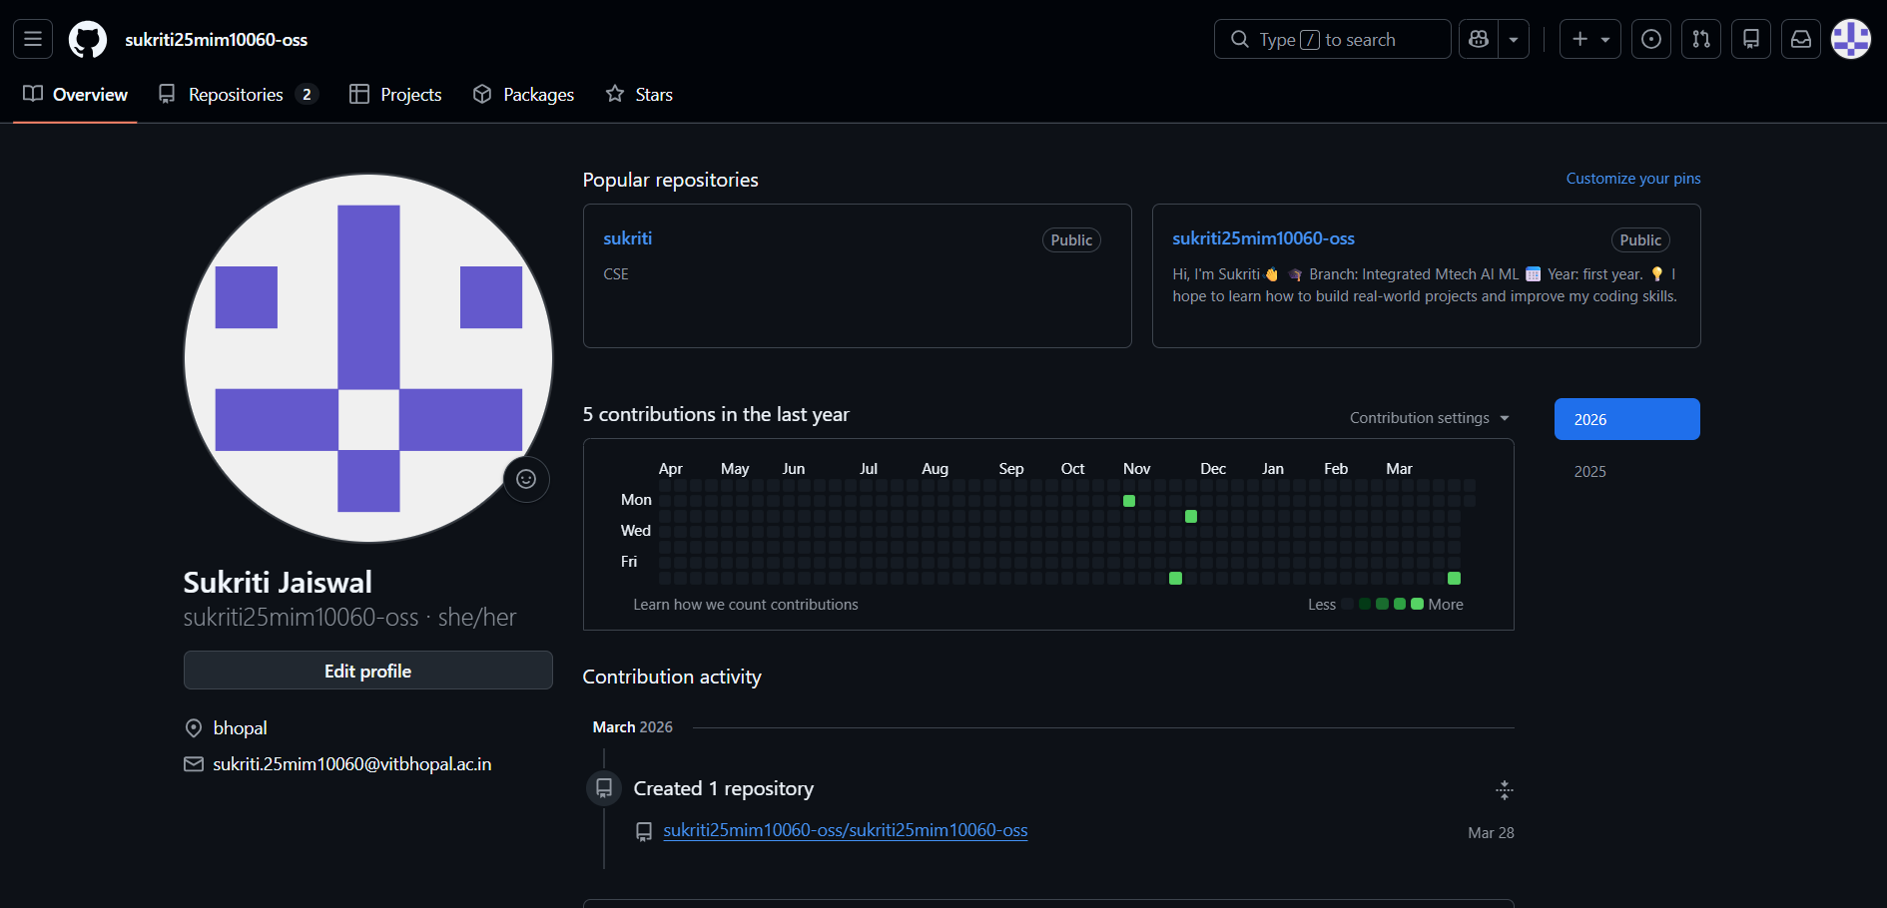

Linkedin profile:

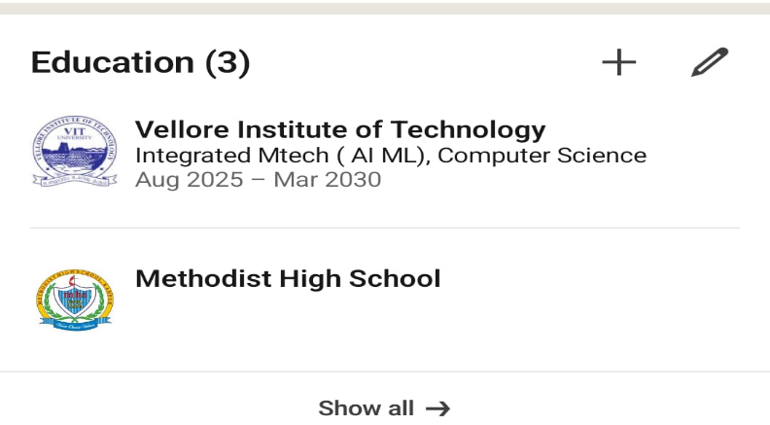

Kaggle Profile:


Task description:
For this task, I chose platforms such as LinkedIn, GitHub, and Coursera because they are widely used for professional growth and learning. LinkedIn is a professional networking platform where individuals can create profiles, connect with others, and explore job opportunities. GitHub is mainly used by developers to store, manage, and share code, as well as collaborate on projects. Coursera is an online learning platform that offers courses from top universities and organizations to build new skills.
Over the next four years, I plan to actively use these platforms to support my academic and career development. On LinkedIn, I will build a strong professional profile, connect with industry professionals, and stay updated with career opportunities. On GitHub, I aim to upload my projects, improve my coding skills, and collaborate with others to gain practical experience. Through Coursera, I will complete relevant courses and certifications to strengthen my knowledge in my field of interest.
Using these platforms consistently will help me enhance my skills, build a professional network, and prepare for future career opportunities.

